3 | Vol 4 | March 2022




`
We want to hear from you! Planning is underway for our Movies in the Park Series at the Martin Hansen Amphitheater. Beginning Friday, June 10th, we will feature a family friendly film in the park at dark. Each film must be appropriate for all ages because the theater is outdoors. Take a few minutes and visit https://forms.gle/DWhWPkqfLU1pFLDN7 to let us know what you’d love to see!
CENSUS & RE-DISTRICTING – NEW 2022
The 2020 census has been completed and boundary lines are being redrawn for federal, state, county, and local jurisdiction precinct boundaries. Boundaries are redrawn in Michigan based on population from the 2020 census information collected. Now that the redistricting process is nearing the final stage, new voter identification cards will be mailed to all registered voters within the City of Eaton Rapids. It is expected the new voter identification cards will be mailed in late spring of 2022 and will reflect the new precinct boundaries. These new precincts will be in effect for the August 2, 2022, Primary Election.

Registration for the Shooting Stars Spring Soccer Season is now Live!
Deadline to Register is 3/18/2022 at 11:45PM.
Shooting Stars is designed for children born 2014-2017. The league consists of 7 weeknight practices (Wednesday OR Thursday) and 5 Saturday morning Games starting the week of April 11th.
**All Games and Practices will be held at the Smithville Soccer Complex
HOW TO REGISTER:
1. Go to cityofeatonrapids.sportngin.com
2. Click on "2021 Shooting Stars Youth Soccer"
3. Create an account or Log-in then follow on-screen prompts
Cost
- $45/player (Player does not have current Parks & Rec Jersey)
- $35/player (Player already has current Parks & Rec Jersey)
*MUST HAVE RED/WHITE PARKS & RECREATION JERSEY TO PARTICIPATE*
Leagues (Based on Birth Year):
2014/2015
2016/2017
Please contact Corey Cagle at ccagle@cityofeatonrapids.com or 517-663-8118 with any questions or concerns!

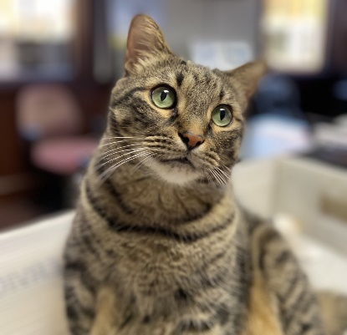

Charlie’s Corner

Hi! My name is Charlie, and I live at City Hall. Some of you may have met me before when you have come into the office to conduct business. If we have not yet met, stop in and say “Hi”!

Tuesday, March 1, 2022 6:00 P.M.
Arts Council Meeting
City of Eaton Rapids, City Hall
200 S. Main St.
Tuesday, March 1, 2022 7:00 P.M.
Parks Development Meeting
City of Eaton Rapids, City Hall
200 S. Main St.
Wednesday, March 2, 2022 6:00 P.M.
River Recreation Meeting
City of Eaton Rapids, City Hall
200 S. Main St.
Monday, March 7, 2022 7:00 P.M.
Planning Commission Meeting
City of Eaton Rapids, City Hall
200 S. Main St.
Friday, March 11, 2022 7:00 A.M.
DDA Board Meeting
City of Eaton Rapids, City Hall
200 S. Main St.
Monday, March 14, 2022 5:00 P.M.
City Council Worksession Meeting
City of Eaton Rapids, City Hall
200 S. Main St.
Monday, March 14, 2022 7:00 P.M.
City Council Regular Meeting
City of Eaton Rapids, City Hall
200 S. Main St.
Tuesday, March 15, 2022 7:00 P.M.
Quality of Life Board Meeting
City of Eaton Rapids, City Hall
200 S. Main St.
Monday, March 28, 2022 5:00 P.M.
City Council Worksession Meeting
City of Eaton Rapids, City Hall
200 S. Main St.
Monday, March 28, 2022 7:00 P.M.
City Council Regular Meeting
City of Eaton Rapids, City Hall
200 S. Main St.

Interesting Fact: Did you know that in 2018 the most popular cat breed was the Exotic-a flat-faced kitty that’s essentially a short-haired version of a Persian cat.

April is Budget Billing sign-up month! If you are already enrolled in the budget billing program, a re-enrollment form will be sent to you. Be sure to complete and return the form promptly to stay enrolled in the program. If you are not already enrolled in the program, we encourage you to do so! To be eligible you must have lived at your current address for 12 consecutive months and have a zero balance on your account. Forms to enroll may be found on our website, in the “Payments” section www.cityofeatonrapids.com. The deadline to enroll is April 30, 2022.

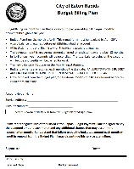

200 S. Main St.
Eaton Rapids, MI 48827
517-663-8118
www.cityofeatonrapids.com

Never miss a payment again! Sign up today for automatic bill pay. Your payment will be automatically deducted from your checking or savings account on the due date of each month. The form can be downloaded on our website in the “payments” screen, or you can stop into City Hall and fill one out today!



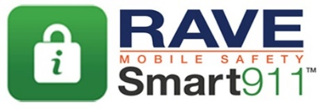

The City will soon be looking to hire for our summer help positions. If you or someone you know may be looking for temporary, summer work, keep an eye on our website, www.cityofeatonrapids.com under the News and Announcements section for more information and when the postings will be active.
The City of Eaton Rapids continues to build our partnership with RAVE Mobile Safety to bring to you an emergency alerts
and notifications messaging system. We encourage
you all to register with the RAVE Mobile Safety
program to stay current and up to date with important news and announcements. After registering, you will be able to receive alerts via phone call, text message, e-mail and social media. To register simply text ERAlerts to 67283 or visit Smart911.com.
Winter Tax Bill Information
Bills were sent on December 1, 2021 and the due date for winter taxes was Monday, February 14, 2022 by 4:00 PM. Any unpaid taxes will be assessed penalties and interest. Payments on past due accounts must be made through Eaton County and are not accepted at City Hall.
Winter Tax Bill Information
Bills were sent on December 1, 2020 and the due date for winter taxes was Tuesday, February 16, 2021 by 4:00 PM. Any unpaid taxes will be assessed penalties and interest. Payments on past due accounts must be made through Eaton County and are not accepted at City Hall after March 1, 2021.
If you or anyone you know has fallen on tough times, there are resources available to assist! Whether the needs if for food, utility bill assistance or mortgage/rent payments, please reach out for assistance. All you need to do is dial 211 from any phone and free, confidential services are available. You’ll be connected to an operator who will take some information and details

