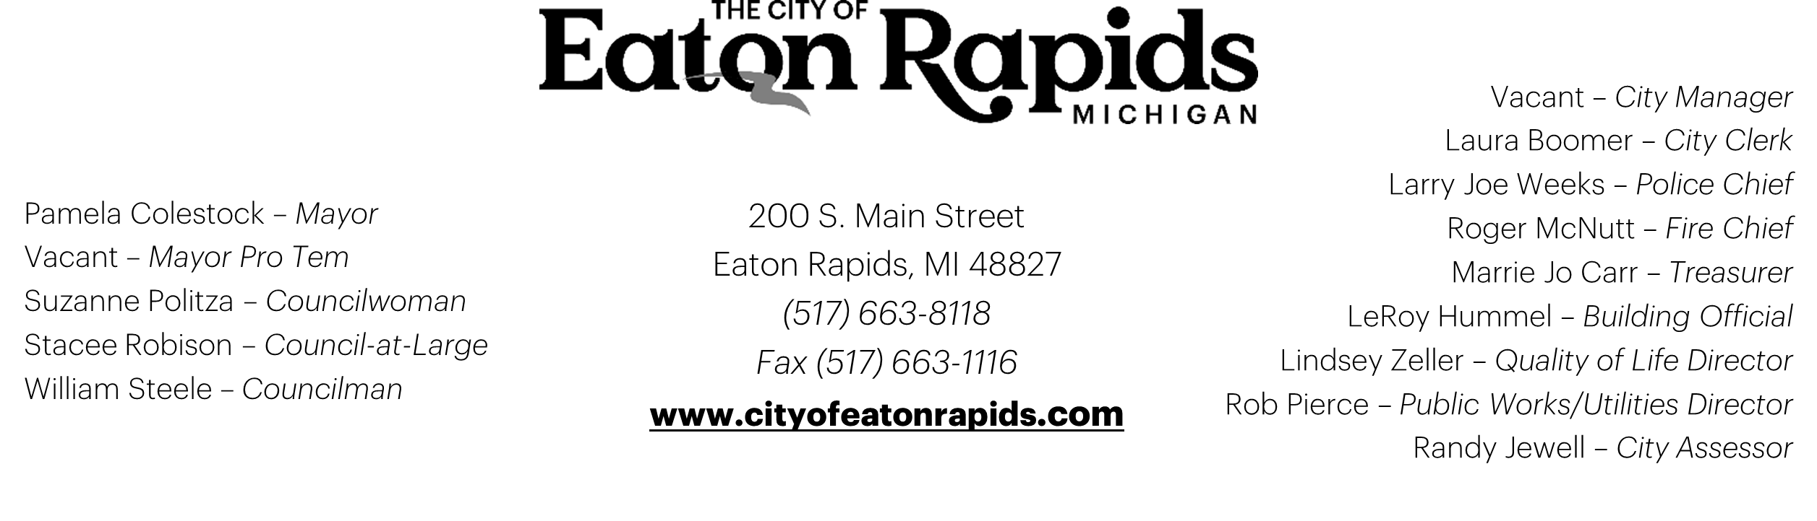

Arts Council Meeting
March 1st, 2022
City Hall – 2nd Floor
6:00 p.m.
AGENDA
- Call to Order and Roll Call
- Approval of Agenda
- Approval of minutes of last meeting
- Public Comments: This item on the agenda is for the public to present comments to or to ask questions of the Parks Development Board Members regarding Agenda Items under Unfinished and Special Business and New Business. Anyone wishing to speak should raise his or her hand to be recognized. And when recognized by the Chair should stand, come to the microphone, give his or her name and address, and proceed with the comments or questions. Time is limited to 3 minutes per comment.

- Unfinished business

  - Grand River Color Tour Triathlon
    - Subcommittee update
  - In-person Classes
  - Virtual Art Class Updates
  - Human Foosball Mural
- New business
- Public Comments: Public Comments. This item on the Agenda is for the public to present comments to or to ask questions of the Parks Development Board Members regarding General Comments. Anyone wishing to speak should raise his or her hand to be recognized, and when recognized by the Chair, should stand, come to the microphone, give his or her name and address, and proceed with comments or questions.

- Correspondence

- Adjournment

