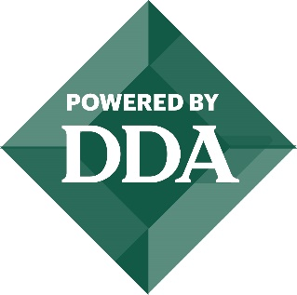
CITY OF EATON RAPIDS
DOWNTOWN DEVELOPMENT AUTHORITY
AGENDA
March 8, 2024
7:00 a.m.
City Hall – 2nd Floor
200 S. Main Street

1. Call to Order
2. Approval of Agenda
3. Citizen Comments (3-minute time limit)
4. Minutes
Approve the minutes from the February 9, 2024, regular DDA Board Meeting.
5. Treasurer Report
Approve the revenue and expense report for the month ending February 29, 2024.
6. Committee Reports
Winter Market
Façade Grant
7. Director Report – Corey Cagle
8. Old Business
9. New Business
a.2024-2025 Budget – Genny Allen
10. Board Member Comments
11. Adjournment

