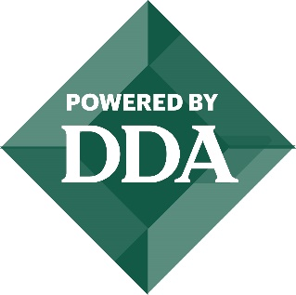
CITY OF EATON RAPIDS
DOWNTOWN DEVELOPMENT AUTHORITY
AGENDA
May 10, 2024
7:00 a.m.
City Hall – 2nd Floor
200 S. Main Street

1. Call to Order
2. Approval of Agenda
3. Citizen Comments (3-minute time limit)
4. Minutes
Approve the minutes from the April 12, 2024, regular DDA Board Meeting.
5. Treasurer Report
Approve the revenue and expense report for the month ending April 30, 2024.
6. Committee Reports
Farmers Market
Façade Grant
7. Approve Façade Grants Awards for 2024.
8. Director Report – Lisa Barna
a. Goal Setting
9. Old Business
10. New Business
11. Board Member Comments
12. Adjournment

